NPS 2320030205

EXPERIMENT-5 N. Manasa Lahari

AIM : **Configuration of Encapsulation dot 1Q using cisco packet tracer**

**Need for VLANs and Dot1Q Encapsulation**

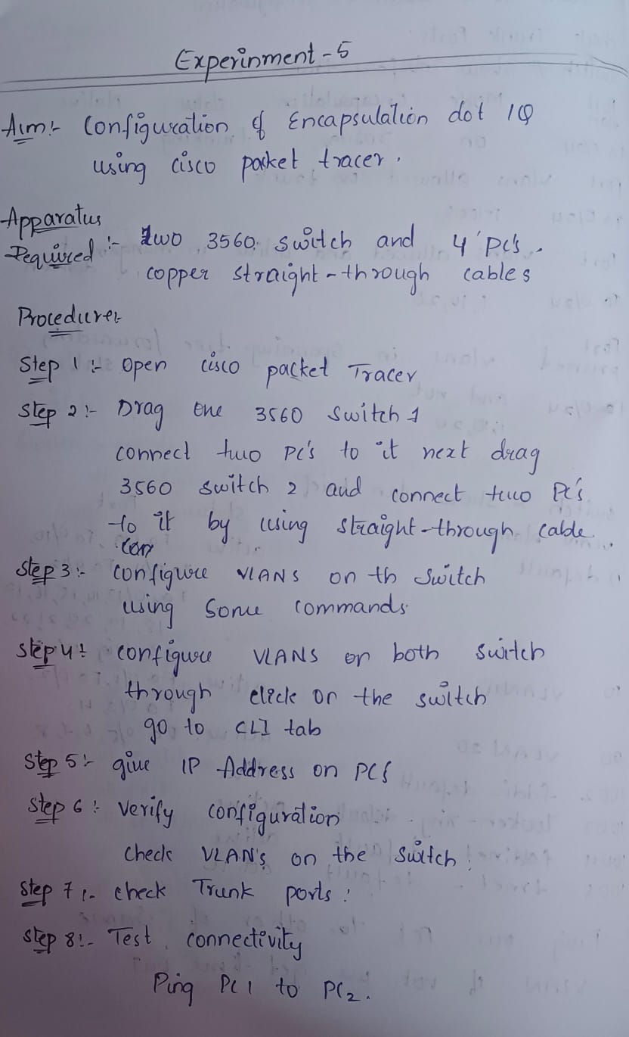

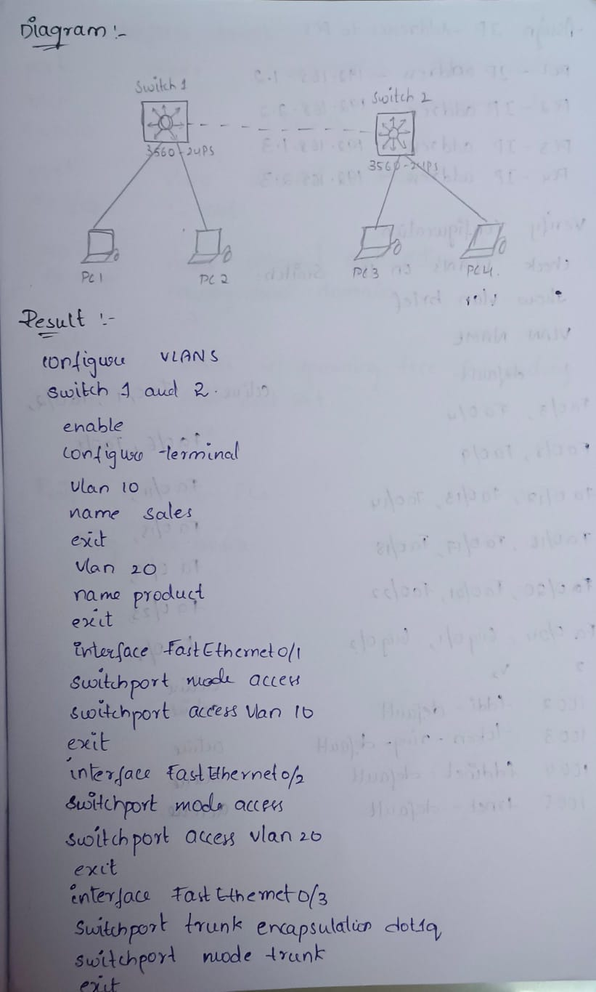

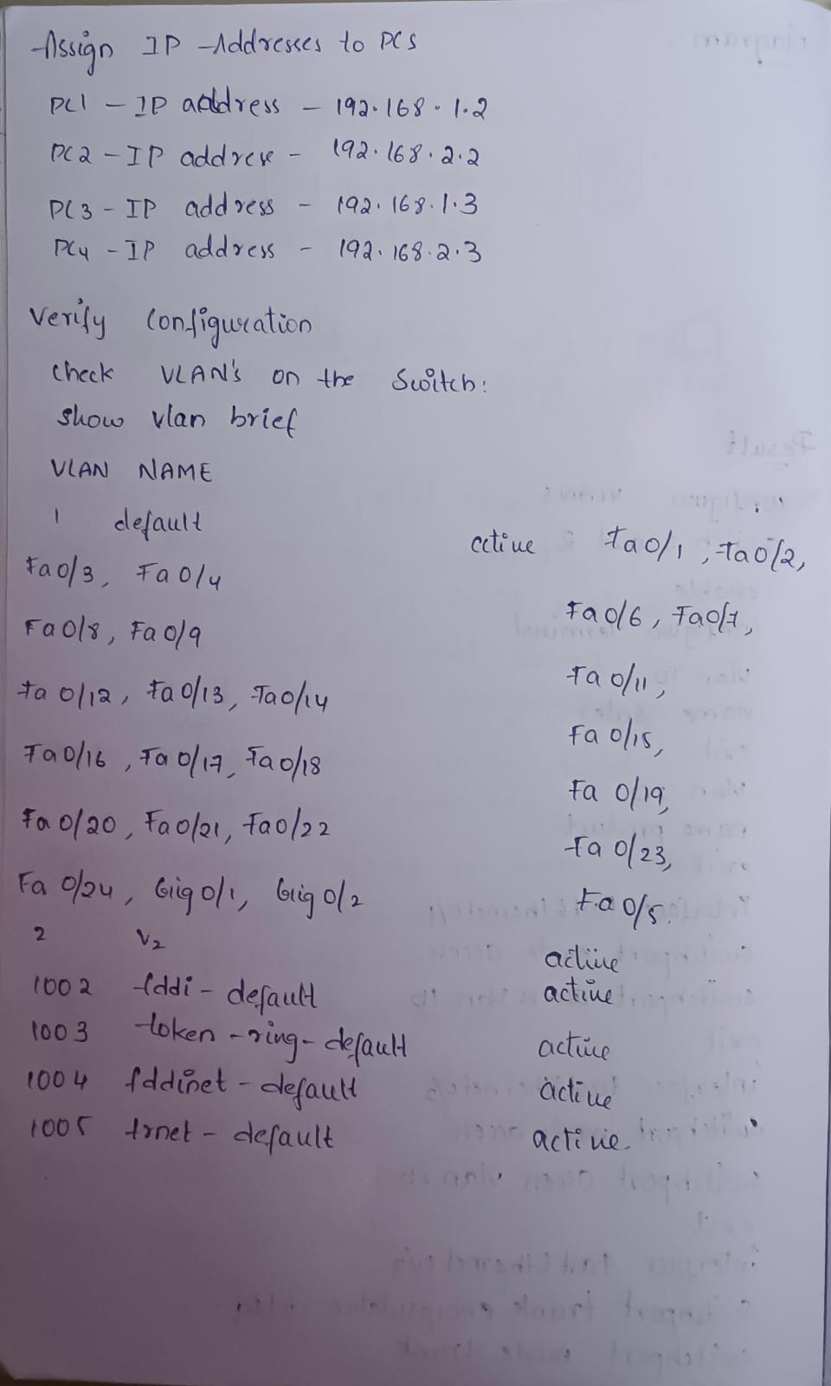

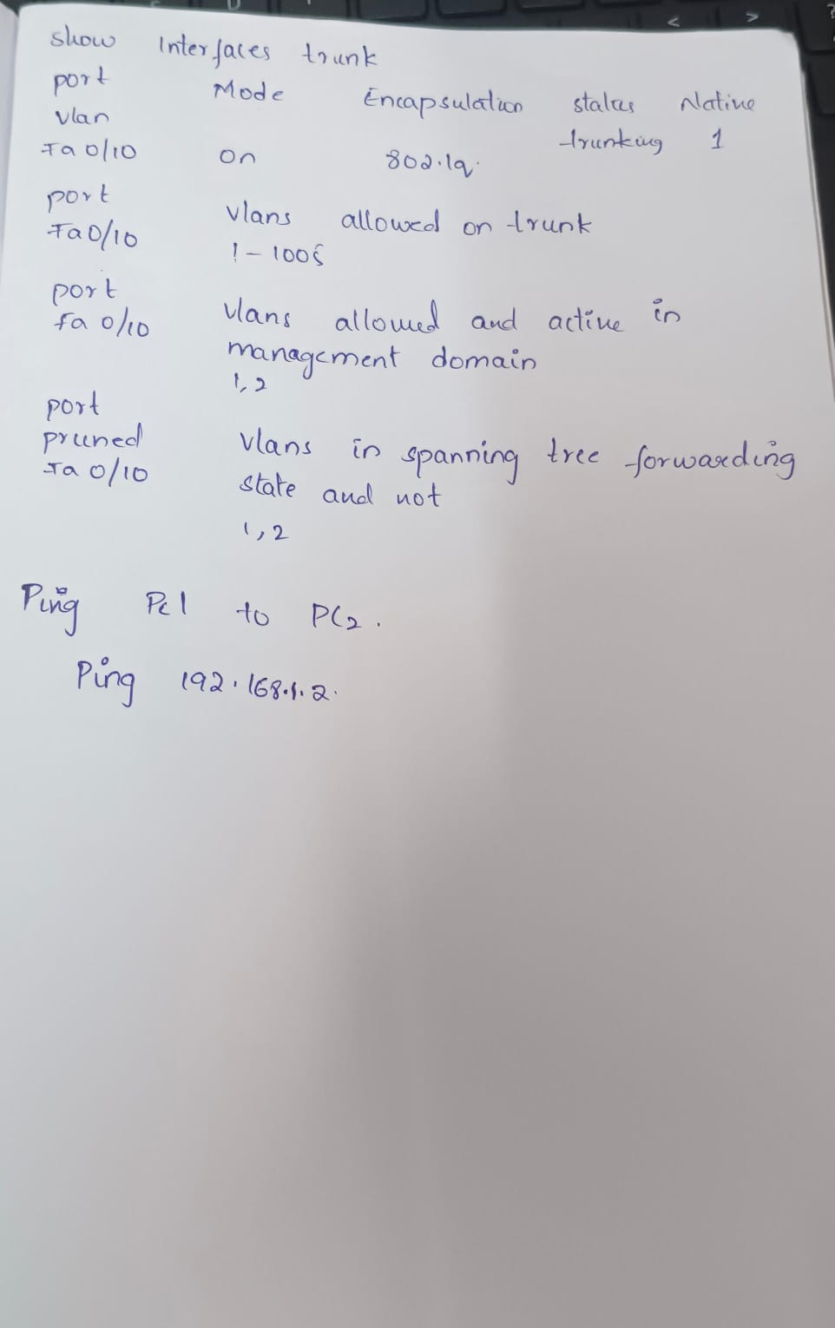

Configure Vlan on Swtiches

Switch 2 (here I have took switch 1 as switch 2)

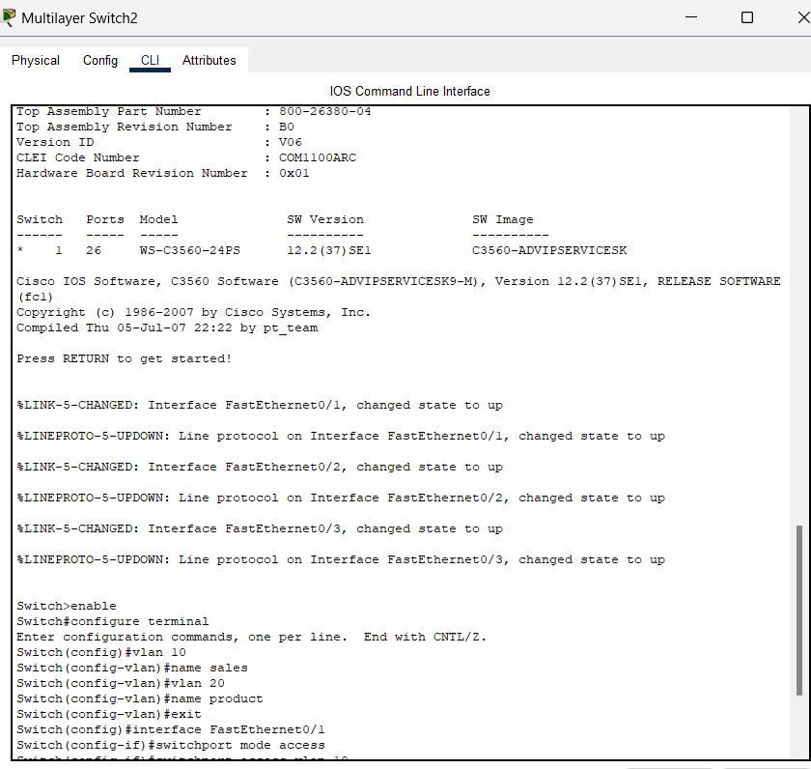

Switch 3 (here I have took switch 2 as switch switch 3)

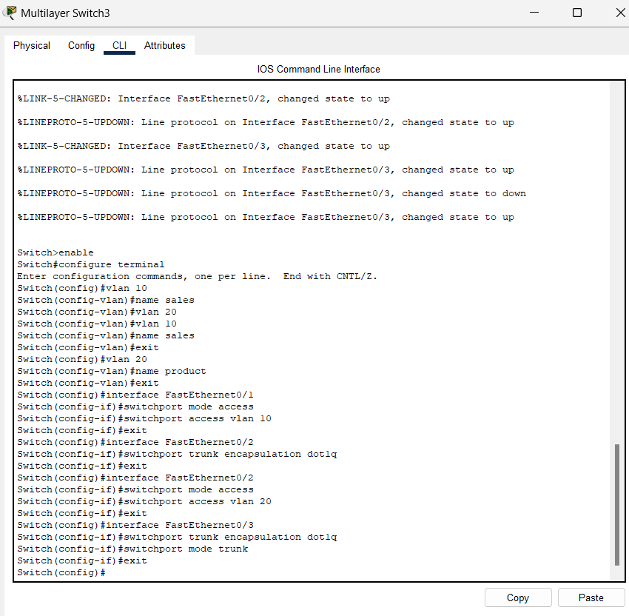

**Assign IP Addresses to PCs**

For pc0

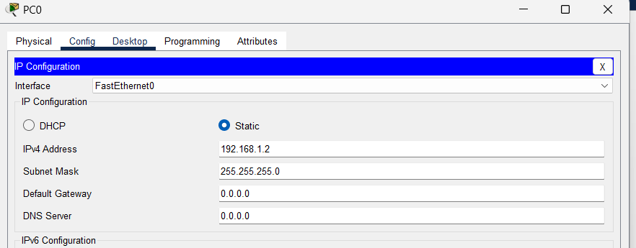

For pc1

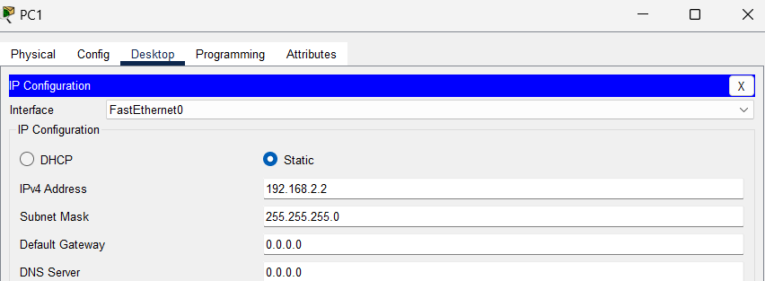

For pc 2

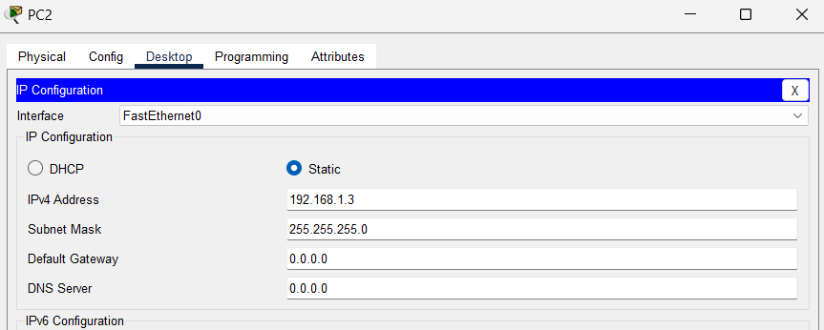

For pc3

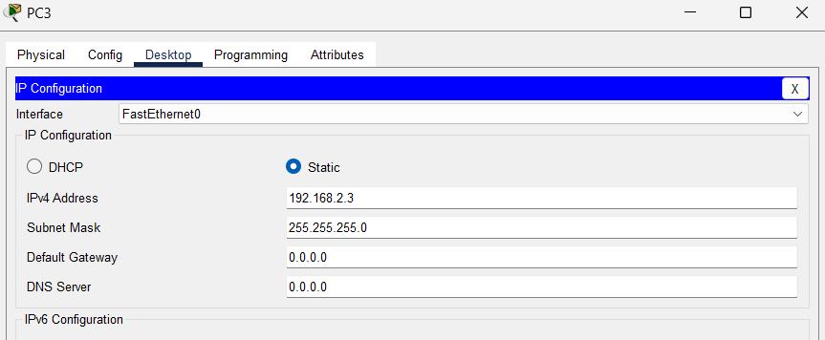

**Verify Configuration**

1. **Check VLANs on the Switch**:

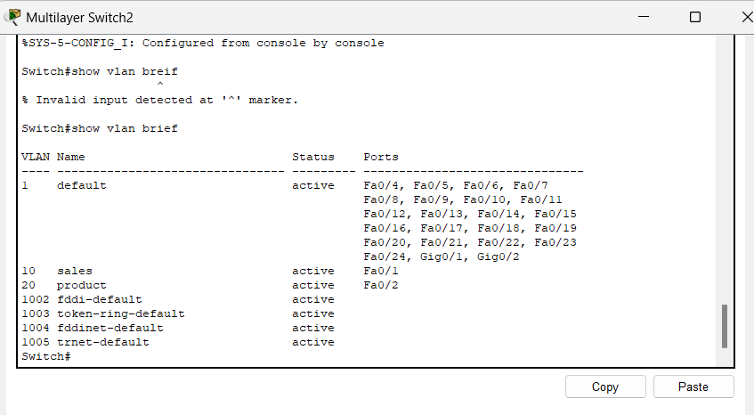

**Check Trunk Ports**

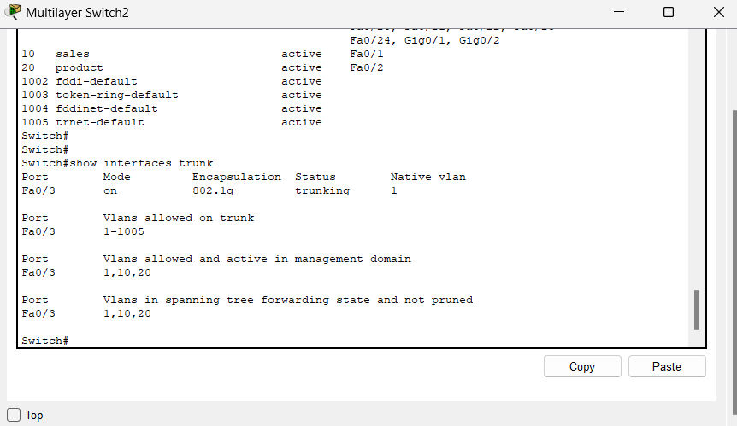

**Test Connectivity**:

